P6/7 Reading Newsletter
World Book Day 2022
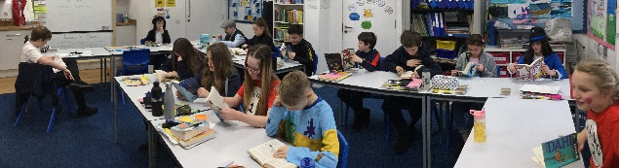
For world book day many of us came dressed as a favourite character from a story. We listened to the World Book Day Rap and had a go at making up a book-themed rap of our own. We wrote a “story companion timeline” and thought back on all our favourite characters from over the years.
Recently I read “Brightstorm”. It is by an author I’ve never heard of before. I really enjoyed the book and would recommend it.
Everyone Reading in Class (ERIC)
We have been enjoying our regular ERIC time. We read for pleasure, and keep a note of what we have read.
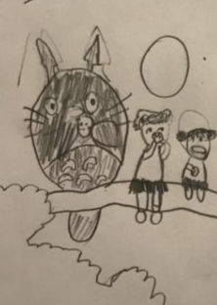
Some of the books we read inspire us in our own creative writing.
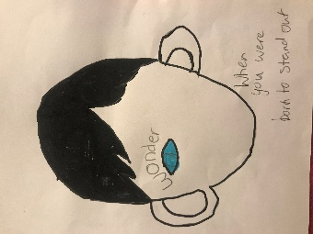
Book Recommendations
We love using our book recommendation wall to tell our friends about the books we’ve read that we think they would enjoy.
Thinking Readers
We have been looking at a “Thinking Reader” approach to our comprehension activities. We have been creating and answering literal, evaluative and inferential questions, and have worked hard on our summarising skills. We are going to teach P3/4/5 some of what we have learnt.
Author Visits
Over the year we have had a wide range of virtual author visits telling us tales of trips to the Tundra, fun stories about Robert Burns and introducing us to some exciting new novels.
Challenge!
P 6/7 love a word challenge like this one! How many words can you find?
Can you unscramble the 10-letter word?
Class Novel
In Class we have been reading “My Neighbour Totoro” which ties in with our Japan topic

News Flash! New Books!
P6/7 are delighted with their new updated library. There is a broad range of authors to choose from for individual reading and for novel studies in groups.
“This term we got some new library books. They are truly wonderful and are from a variety of different authors”
“I’m really enjoying The Windrush Child. It’s really interesting to learn about the experience of a child from Jamaica who moves to Manchester”
R
I
U
E
L
A
T
T
R
E

